**AI-ENHANCED PERSONALIZED LEARNING SUPPORT SYSTEM**

**ABSTRACT**

The limitations of current e-learning platforms have become evident as the demand for ongoing skill development in our rapidly evolving, tech-centric world increases. While platforms like Coursera and Udemy offer extensive resources, their reliance on uniform, inflexible learning trajectories often fails to cater to individual requirements. Learners find it challenging to maintain existing competencies while acquiring new ones, resulting in inefficient learning and skill erosion. This study introduces an AI-Enhanced Personalized Learning Support System, a groundbreaking approach that revolutionizes education through adaptive, customized, and dynamic methodologies. By harnessing AI, the system crafts individualized learning paths, creates adaptive assessments, and delivers instant feedback on language and writing skills. A comprehensive monitoring interface allows mentors and organizations to observe progress, recognize knowledge gaps, and implement targeted support. The platform also incorporates collaborative features such as discussion boards and instant messaging tools, promoting peer learning and information sharing. This innovative system, designed to benefit both individuals and institutions, redefines personalized education by ensuring learners stay aligned with their objectives while adapting to the constantly shifting demands of the contemporary landscape.

**KEYWORDS :** Personalized Learning , Artificial Intelligence (AI), Adaptive Assessments, Skill Tracking, Skill Maintenance ,Dynamic Learning Pathways , AI in Education , E-Learning Platforms, AI-Generated Quizzes , Lifelong Learning , Recommendation Systems , Collaborative Learning, Community Engagement

**INTRODUCTION**

In today's fast-paced technological landscape, the necessity for individuals and organizations to acquire and hone new skills has become crucial. While platforms like Coursera, Udemy, and edX have made education more accessible, offering a plethora of resources across various fields, their reliance on static, interest-based suggestions often fails to address the specific strengths, weaknesses, and evolving objectives of each learner [1]. This discrepancy results in ineffective learning, where users either revisit familiar content or struggle to maintain existing abilities while exploring new ones. The rapidly shifting skill requirements in modern workplaces further exacerbate this inefficiency [5].

Conventional e-learning platforms lack the ability to provide tailored guidance, instead offering generic learning paths that don't adapt to changing user needs. This uniform approach is ill-suited to accommodate the diverse learning speeds, proficiency levels, and career goals of individual users [2]. Moreover, learners frequently encounter skill decay, where infrequent application of acquired knowledge leads to a gradual loss of proficiency [3]. Tackling these issues requires an innovative, flexible, and personalized approach to education.

Artificial Intelligence (AI) has emerged as a revolutionary force across various industries, including education. The integration of AI in educational settings has the potential to create more individualized and effective learning experiences [4]. AI's capacity to deliver ongoing feedback and support further enhances its ability to personalize learning [6]. By leveraging AI technology, personalized learning systems can surmount the limitations of traditional platforms. These systems can dynamically adjust to learners' progress, offer customized recommendations, and provide continuous assistance to ensure effective skill acquisition and retention.

This research introduces an AI-Enhanced Personalized Learning Support System aimed at transforming the e-learning experience. The proposed platform delivers customized learning pathways tailored to individual requirements, AI-generated quizzes for dynamic skill evaluation, and real-time support for language and writing abilities. It equips mentors and organizations with tools to track learner progress and promotes collaborative learning through community features. The system not only addresses existing shortcomings but also ensures learners remain aligned with their objectives in a structured, efficient, and engaging manner..

**RELATED WORKS**

With growing demands for custom and effective learning experiences, a massive study was conducted in educational technology and AI fields. The thrust of these educational systems has been to optimize learning based on diverse student populations, hence making it imperative to understand how technology can enhance learning experiences. This literature review considers the current work in the area of personalized learning systems, adaptive learning technologies, recommendation systems in education, skill maintenance strategies, and broader applications of AI in education. It provides an overview of the state of research at this point and points out key gaps that this work addresses, particularly with regard to skill maintenance and personalized learning pathways.

**EVOLUTION OF E-LEARNING PLATFORMS**

E-learning platforms, including Coursera, Udemy, and Khan Academy, have revolutionized the education sector with rapid growth by democratizing access to diverse learning resources [7]. The platform has changed traditional learning methods in which learners can access materials at their own pace and convenience. Despite the wide range of content, these platforms primarily depend on static pathways and predefined course recommendations based on general user interests. Research identifies such approaches often fail to capture individual learning needs of users and invariably incur inefficiency in the acquisition of skills, engagement, and retention. Generalized pathways are presented before learners, which may not ideally fit their unique learning styles, goals, or levels of progress. It is, therefore, becoming increasingly important to develop more personalized adaptive learning systems that can cater to individual learners' specific needs. These platforms are now exploring advanced technologies like artificial intelligence and machine learning to create more tailored learning experiences. By analyzing user data and behavior patterns, these systems aim to provide personalized course recommendations and adaptive learning paths. This shift towards individualized learning is expected to significantly improve learner engagement, skill acquisition efficiency, and overall educational outcomes.

**ARTIFICIAL INTELLIGENCE IN EDUCATION**

In integrating AI into education technology, many benefits have been accrued in the area of personalizing learning experiences. Such AI-based systems as intelligent tutoring systems (ITS) and adaptive learning environments have been reported to be great tools for individualizing the process of learning [8]. A study has established that AI can dynamically modify the delivery of content and the assessments of a learner based on their unique capability, goals, and progress [9]. These systems use the power of machine learning algorithms in real-time, which can generate improved learning results. However, current AI is often narrow and limited in scope, focusing usually on a given domain or set of subjects. It does not provide holistic support for tracking skills and pathways to comprehensive learning. Support a more integrated approach from beginning to the end of one's educational path: not just the delivery but continuous retention and mastery of their skills. To address these limitations, future AI systems in education should strive for a more comprehensive and integrated approach. This could involve developing sophisticated AI platforms that can track and support a learner's progress across multiple subjects and domains throughout their entire educational journey, from early childhood through higher education and beyond. Such advanced systems would not only focus on efficient content delivery but also emphasize long-term skill retention, knowledge application, and mastery of complex concepts.

These next-generation AI educational tools would provide continuous support and guidance, adapting to the learner's changing needs and evolving cognitive abilities. By leveraging machine learning algorithms and natural language processing, these systems could offer personalized feedback, identify knowledge gaps, and suggest targeted interventions to enhance learning outcomes. Furthermore, they could incorporate elements of cognitive science and educational psychology to optimize the learning process, ensuring that information is presented in ways that maximize retention and facilitate deep understanding.

By integrating data from various learning experiences, assessments, and even extracurricular activities, these advanced AI systems could offer a more holistic view of a learner's capabilities, interests, and potential. This comprehensive approach would enable educators and learners to make more informed decisions about educational pathways, career choices, and personal development goals. The AI could analyze patterns in learning behaviors, identify strengths and areas for improvement, and suggest tailored educational strategies that align with individual learning styles and preferences.

Moreover, these future AI systems could foster collaboration and peer-to-peer learning by connecting students with similar interests or complementary skills. They could facilitate virtual study groups, project-based learning experiences, and cross-disciplinary collaborations, preparing students for the interconnected and rapidly evolving job market of the future. By incorporating real-world problem-solving scenarios and simulations, the AI could help bridge the gap between theoretical knowledge and practical application, ensuring that learners are well-equipped to face challenges in their future academic and professional endeavors.

Additionally, these advanced AI educational platforms could integrate seamlessly with emerging technologies such as virtual and augmented reality, providing immersive learning experiences that cater to diverse learning modalities. This multi-sensory approach could enhance engagement, improve information retention, and make complex concepts more accessible and intuitive for learners of all abilities.

In conclusion, by developing AI systems that offer a more holistic, adaptive, and long-term approach to education, we can create learning environments that are truly responsive to individual needs and goals. These advanced AI tools have the potential to revolutionize education, fostering lifelong learning, critical thinking, and adaptability – skills that are essential for success in an increasingly complex and dynamic world.

**ADAPTIVE ASSESSMENTS AND SKILL DECAY**

Adaptive assessment is one powerful tool in modern personalization efforts. Adaptive assessment is the approach using machine learning algorithms to create items that fit a learner's profile, adjust on the fly and offer a real view of skills possessed by them [10]. This approach creates a challenging and supportive learning experience, ensuring that learners are continuously challenged at an appropriate level, which promotes skill development and mastery. Moreover, research on skill decay emphasizes the importance of regular practice and assessment in maintaining proficiency, particularly in areas where skills can deteriorate over time without continued engagement [11]. Adaptive learning systems that incorporate periodic assessments can effectively combat skill decay by offering targeted, ongoing practice opportunities that keep learners’ skills sharp.

**PERSONALIZED PATHWAYS AND GOAL SETTING**

Research on personalized learning pathways has demonstrated that tailoring learning plans to match individual goals, strengths, and weaknesses significantly enhances engagement and improves learning outcomes [12]. Traditional educational systems tend to neglect the dynamic needs of learners since most are designed linearly with one-size-fits-all curricula. However, AI adaptive systems can offer the possibility of dynamically changing pathways with the learner. The systems adjust content, pace, and goals as required while tracking real-time learner progress in order to make the learning experience relevant and challenging. This openness promotes increased learner involvement and the drive to achieve improvement since learning is closely matched with the growth of the capabilities and goals of the learner. AI-powered adaptive learning systems can also provide immediate feedback and targeted interventions, allowing learners to address misconceptions and knowledge gaps in real-time. This personalized approach fosters a growth mindset, encouraging learners to view challenges as opportunities for improvement rather than insurmountable obstacles. Furthermore, by leveraging data analytics and machine learning algorithms, these systems can identify patterns in learning behaviors and preferences, enabling educators to make informed decisions about curriculum design and instructional strategies.

**COMMUNITY LEARNING AND COLLABORATION**

Other than personalized learning, community-based learning has also become advantageous in retaining knowledge and developing skills. Tools like Edmodo and Discord have emerged to promote peer-to-peer interactions and group discussions [13]. Research has shown that social interaction plays a crucial role in cognitive development, and it is through collaboration and community involvement that learning becomes more effective [14]. In this regard, community-driven features in e-learning can help foster interpersonal skills, facilitate knowledge sharing, and offer opportunities for learners to engage in problem-solving activities with their peers. These collaborative environments support not only cognitive development but also a sense of community, which can enhance motivation and retention.

**GAPS IN EXISTING SYSTEMS**

Existing systems, despite the significant advancements in e-learning and AI, still face several challenges and gaps that hinder their effectiveness. These include:

1. **Real-time Skill Tracking Mechanisms:** In Real-time skill tracking mechanisms; although most E-learning platforms trace learner progress, most of these do not include more complex tracking mechanisms that have the ability to monitor in real time skill acquired and those requiring improvement [15].
2. **Dynamic Quizzes Tailored to Individual Performance:** Many platforms rely on static quizzes or assessments, which do not adapt to the learner's changing capabilities. Personalized, dynamic quizzes that adjust based on learner performance are essential for ongoing skill development and mastery.
3. **Comprehensive Dashboards for Mentors:** While some platforms provide basic reporting features, they often lack comprehensive dashboards that allow mentors and instructors to effectively monitor and guide learners.
4. **Community Features that Encourage Collaborative and Lifelong Learning:** Though social interaction plays a critical role in learning, most platforms fail to include strong community features that will adequately support peer interaction, group learning, and social support.

These gaps point to the need for more advanced, AI-based e-learning systems that can provide adaptive, personalized learning experiences while promoting collaborative and community-driven learning. This research will address these gaps by proposing an AI-powered platform that personalizes learning content and assessments while supporting ongoing skill retention, real-time performance tracking, and community engagement.

**MATERIALS AND METHODS**

This segment outlines the structure and blueprint of the suggested AI-powered customized learning assistance platform. The system aims to deliver tailored educational pathways, support ongoing skill upkeep, and offer instant help to students. Its design adopts a modular strategy, with each element handling specific functions, ensuring the system's adaptability, expandability, and efficacy.

The platform's framework is composed of interlinked modules that collaborate to provide a holistic learning journey. The core of the system encompasses the User Interface (UI), User Profile Management, Learning Resource Database, Recommendation Engine, Skill Maintenance Module, Real-time Assistance Module, and Mentor/Organization Management Module.

**A. SYSTEM OVERVIEW**

The structure of the AI-Enhanced Personalized Learning Support System is modular, consisting of interconnected elements that function in unison to deliver a comprehensive and individualized educational experience. The system is engineered with scalability and ease of maintenance in mind, allowing for future growth and incorporation of new capabilities. The primary components, as shown in Figure 1, include: the User Interface (UI), User Profile Management, Learning Resource Database, Recommendation Engine, Skill Maintenance Module, Real-time Assistance Module, and Mentor/Organization Management Module.

**Figure 1: Personalized Learning Support System Architecture**

1. **User Interface (UI):** The user interface serves as the primary point of interaction for all users: learners, mentors, and administrators. It is designed to be accessible across multiple platforms (web and mobile) to cater to diverse user preferences and contexts.

* **Learner Perspective:** Learners use the UI to access personalized learning paths, engage with learning resources (articles, videos, quizzes), track their progress, receive feedback, and communicate with mentors and peers. The UI provides visualizations of learning progress, skill mastery levels, and upcoming learning activities.
* **Mentor Perspective:** Mentors utilize the UI to monitor learner progress, identify areas where learners are struggling, provide personalized feedback and guidance, and communicate with learners individually or in groups. The UI provides dashboards with aggregated learner data and analytics.
* **Administrator Perspective:** Administrators use the UI to manage users, learning resources, system settings, and generate reports on system usage and effectiveness.

1. **User Profile Management:** This module is responsible for managing and maintaining essential user data. This includes:

* **User Information:** Basic user details (name, contact information, etc.).
* **Learning Preferences:** Preferred learning styles ,learning pace, and preferred content formats.
* **Skills and Interests:** Current skills, areas of interest, and learning goals.
* **Learning History:** Completed courses, quiz scores, time spent on learning activities, and feedback received.
* **Dynamic Profile Updates:** The module dynamically updates user profiles based on user interactions with the system. For instance, if a learner consistently performs well in quizzes on a specific topic, their proficiency in that area is updated in their profile. This dynamic updating enables the system to provide increasingly personalized recommendations and learning paths.

1. **Learning Resource Database:** This module acts as a central repository for storing and organizing all learning materials.

* **Resource Types:** The database stores various types of learning resources, including articles, videos, interactive exercises, simulations, and external links.
* **Metadata and Tagging:** Each resource is associated with metadata, including title, author, description, keywords, learning objectives, difficulty level, and prerequisites. This metadata is used by the recommendation engine for content-based filtering.
* **Organization and Indexing:** The resources are organized into a structured taxonomy or knowledge graph to facilitate efficient retrieval and navigation.

1. **Recommendation Engine:** This module is the core of the personalized learning experience. It generates personalized learning paths and resource recommendations based on user profiles and the learning resource database.

* **Hybrid Recommendation Approach:** As described previously, the engine combines content-based filtering (using TF-IDF and Word2Vec/GloVe) and collaborative filtering (using matrix factorization) to provide more accurate and diverse recommendations.
* **Contextual Recommendations:** The engine also considers contextual factors such as the learner's current learning activity, time of day, and learning environment to provide more relevant recommendations.

1. **Skill Maintenance Module:** This module is dedicated to addressing skill decay by creating and delivering AI-generated adaptive quizzes and spaced repetition exercises.

* **Adaptive Quiz Generation:** The module generates quizzes that adapt to the learner's performance. If a learner answers a question correctly, subsequent questions become more challenging. If a learner answers incorrectly, the system provides easier questions or reviews related content.
* **Spaced Repetition Scheduling:** The module schedules review sessions based on spaced repetition algorithms, which have been shown to be highly effective in promoting long-term retention.
* **Skill Tracking and Monitoring:** The module tracks learner performance on quizzes and provides feedback on skill mastery levels.

1. **Real-time Assistance Module:** This module provides immediate feedback and support to learners in various areas.

* **Grammar and Writing Feedback:** Using NLP techniques, the module provides feedback on grammar, spelling, punctuation, and writing style.
* **Pronunciation Feedback:** Using speech recognition technology, the module provides feedback on pronunciation and intonation.
* **Automated Essay Scoring:** The module uses machine learning models to provide automated feedback on essay quality, including grammar, vocabulary, organization, and coherence.

1. **Mentor/Organization Management Module:** This module provides tools for mentors and organizations to manage learners and track progress.

* **Learner Management:** Mentors can manage learner groups, assign learning paths, and communicate with learners.
* **Progress Tracking and Reporting:** The module provides dashboards and reports that visualize learner progress, skill mastery levels, and areas of strength and weakness.
* **Communication Tools:** The module provides communication tools for mentors and learners to interact, including messaging, forums, and video conferencing.

**B. PERSONALIZED LEARNING PATH GENERATION**

The generation of personalized learning paths is powered by a hybrid recommendation engine that strategically combines content-based filtering and collaborative filtering techniques to provide a more robust and personalized learning experience. The process, illustrated in Figure 2, begins with user profile creation.

**Figure 2: Personalized Learning Path Generation Process**

**User Profile Creation and Skill Assessment:** When a user first registers, they create a profile by providing information about their current skills, interests, learning goals, and preferred learning styles (e.g., visual, auditory, kinesthetic). To assess the learner's initial skill level within their chosen domain(s), a diagnostic quiz or self-assessment is conducted. This assessment is designed to identify existing knowledge gaps and strengths, providing a baseline for personalized recommendations. The results of the assessment are stored in the user's profile and used by both the content-based and collaborative filtering components.

**Content-Based Filtering:**

Content-based filtering analyzes the learning materials (e.g., articles, videos, exercises) to match resources with the learner's interests and identified knowledge gaps. This process utilizes Natural Language Processing (NLP) techniques:

* **Text Preprocessing:** The text content of learning resources is preprocessed, including tokenization (splitting text into individual words or phrases), stop word removal (removing common words like "the," "a," "is"), and stemming/lemmatization (reducing words to their root form).
* **Feature Extraction:** Two primary methods are used for feature extraction:
* Term Frequency-Inverse Document Frequency (TF-IDF): TF-IDF measures the importance of a word within a document relative to a collection of documents (corpus). Words that appear frequently in a specific resource but rarely in the overall corpus are given higher weights, indicating their relevance to that resource's topic.
* **Word Embeddings (Word2Vec or GloVe):** Word embeddings represent words as dense vectors in a high-dimensional space, capturing semantic relationships between words. This allows the system to identify resources that are semantically similar to the user's interests or identified knowledge gaps, even if they don't share exact keywords.
* **Profile Matching:** The user's profile (interests, goals, and assessed skills) is also represented as a vector using the same feature extraction method as the learning resources. The system then calculates the similarity between the user profile vector and the resource vectors using cosine similarity. Resources with high cosine similarity scores are considered relevant to the user.

**Collaborative Filtering:**

* Collaborative filtering identifies learners with similar learning patterns and recommends resources that have been successful for those users. This approach uses user-item interaction data (e.g., resource views, completion rates, ratings):
* **User-Item Matrix:** A user-item matrix is constructed, where rows represent users, columns represent learning resources, and the cells contain values indicating user interactions (e.g., 1 for completed, 0 for not completed, or a rating score).
* **Matrix Factorization (e.g., Singular Value Decomposition (SVD) or Alternating Least Squares (ALS)):** Matrix factorization techniques decompose the user-item matrix into two lower-dimensional matrices representing user and item latent factors. These latent factors capture underlying user preferences and item characteristics.
* **Recommendation Generation:** By multiplying the user and item latent factor matrices, the system can predict how a user would interact with resources they haven't yet encountered. Resources with high predicted interaction scores are recommended to the user.

**Hybrid Approach:**

The hybrid approach combines the recommendations from both content-based and collaborative filtering to generate the final personalized learning path. This addresses the limitations of each individual approach:

* **Weighted Averaging:** A simple approach is to calculate a weighted average of the recommendation scores from the content-based and collaborative filtering components. The weights can be adjusted based on the availability of user-item interaction data (collaborative filtering is more effective with more data) or the user's specific learning goals.
* **Switching:** Another approach is to use one method as the primary recommendation method and switch to the other based on certain criteria (e.g., if there is insufficient user-item interaction data for collaborative filtering, the system relies more on content-based filtering).
* **Feature Combination:** A more sophisticated approach is to combine the features extracted by both methods and use a machine learning model (e.g., a regression model or a ranking model) to generate the final recommendations.

**Learning Path Organization and Adaptation:**

Once the relevant resources are identified, they are organized into a structured learning path, ensuring that content is delivered in a logical sequence that aligns with the learner’s objectives and prerequisites. The learning path evolves over time, adapting as the learner progresses. If a learner masters a concept quickly, the system can accelerate their path. Conversely, if a learner struggles with a particular topic, the system can provide additional resources or revisit earlier concepts. This dynamic adaptation ensures that the learning path remains personalized and effective throughout the learner's journey.

**C. SKILL MAINTENANCE MODULE**

The Skill Maintenance Module is designed to combat skill decay and promote long-term retention of learned knowledge. It achieves this through a combination of AI-generated adaptive quizzes, spaced repetition scheduling, and performance analysis, as illustrated in Figure 3.

**Figure 3 : Skill Maintenance Module Process**

**1. Quiz Generation:**

* **NLP-Based Question Extraction:** The module utilizes Natural Language Processing (NLP) techniques to automatically generate quiz questions from the learning resources stored in the Learning Resource Database.
* **Knowledge Graph Integration:** A knowledge graph, representing the relationships between concepts and topics within the learning domain, is used to guide question generation. This ensures that questions cover a range of related concepts and promote deeper understanding.
* **Question Type Generation:** The module generates various question types, including:
  + **Multiple-Choice Questions (MCQs):** Generated by identifying key concepts and creating plausible distractors (incorrect answer options) using techniques like word embeddings or synonym extraction.
  + **Fill-in-the-Blank Questions:** Generated by removing key words or phrases from sentences and requiring the learner to fill in the missing words.
  + **True/False Questions:** Generated by creating statements related to the learning content and requiring the learner to determine their truth value.
* **Question Difficulty Tagging:** Each generated question is tagged with a difficulty level (e.g., easy, medium, hard) based on factors such as word frequency, sentence complexity, and the depth of understanding required to answer the question.

**2. Question Selection and Adaptive Difficulty:**

* **Initial Quiz Generation:** When a learner initiates a skill maintenance quiz, the module selects a set of questions based on the learner's learning history and knowledge gaps identified through previous assessments and interactions with the system. The initial difficulty of the quiz is determined based on the learner's overall proficiency in the relevant skill area.
* **Adaptive Difficulty Adjustment (Item Response Theory - IRT or similar):** The difficulty of subsequent questions is dynamically adjusted based on the learner's performance on previous questions. Item Response Theory (IRT) or similar psychometric models are used for this adaptation.
  + **IRT Model:** IRT models the probability of a learner answering a question correctly as a function of the learner's ability and the question's difficulty. By tracking the learner's responses, the system can estimate their ability level and select subsequent questions with appropriate difficulty.
  + **Dynamic Adjustment:** If a learner answers a question correctly, the system selects a more difficult question next. If a learner answers incorrectly, the system selects an easier question or presents a question on a related but simpler concept. This ensures that learners are continuously challenged at an appropriate level, maximizing learning and minimizing frustration.

**3. Quiz Scheduling:**

* **Manual Scheduling:** Learners can manually set the frequency of their skill maintenance quizzes (e.g., daily, weekly, bi-weekly).
* **System-Suggested Frequency (Spaced Repetition Algorithms):** The system also suggests optimal quiz schedules based on spaced repetition algorithms. These algorithms, such as the Leitner system or SM-2, determine the optimal intervals for reviewing learned material to maximize retention.
  + **Performance-Based Adjustment:** The system continuously monitors the learner's performance on quizzes and adjusts the suggested quiz schedule accordingly. If a learner consistently performs well on reviews, the intervals between reviews are increased. If a learner struggles with certain concepts, the intervals are decreased.

**4. Performance Analysis and Feedback Loop:**

* **Knowledge Graphs:** The module maintains knowledge graphs for each learner, representing their understanding of different concepts and their relationships. Performance on quizzes is used to update these knowledge graphs, providing a visual representation of the learner's progress and identifying areas where they need further review.
* **Skill Retention Analysis:** The module tracks skill retention over time by analyzing learner performance on quizzes. This data is used to refine the quiz scheduling algorithms and identify areas where the learning materials or quiz questions may need improvement.
* **Feedback Loop:** The performance analysis feeds back into the question selection and adaptive difficulty adjustment processes, creating a continuous cycle of improvement and personalization. The system also provides feedback to the learner on their performance, highlighting areas of strength and weakness.

**5. Balanced Quiz Composition:**

Each quiz is designed to include a balanced mix of questions:

* **Existing Skills (70-80%):** Questions that review previously learned material to reinforce long-term retention.
* **Newly Learned Content (20-30%):** Questions that assess the learner's understanding of recently learned material.

**D. REAL-TIME ASSISTANCE MODULE**

The Real-time Assistance Module provides immediate, actionable feedback to learners in three key areas: grammar checking, pronunciation feedback, and essay grading. This module leverages various Natural Language Processing (NLP) and speech recognition technologies to provide a comprehensive and effective learning experience, as illustrated in Figure 4.

**Figure 4: Real-time Assistance Module Workflow**

**1. Grammar Checking:**

* **Input Processing:** The learner inputs text through the UI.
* **NLP Techniques:** The module employs several NLP techniques to analyze the input text:
  + **Tokenization:** The input text is broken down into individual words or phrases (tokens).
  + **Part-of-Speech (POS) Tagging:** Each token is assigned a grammatical category (e.g., noun, verb, adjective). This helps identify grammatical errors related to word usage.
  + **Syntactic Parsing:** The module analyzes the sentence structure to identify errors in syntax, such as subject-verb agreement, incorrect word order, and missing punctuation. Dependency parsing is often used to establish relationships between words in a sentence.
  + **Error Detection:** Based on the POS tags and syntactic parse tree, the system identifies potential grammatical errors. Rule-based systems and statistical models trained on large corpora of grammatically correct text are used for error detection.
* **Feedback Generation:** The module generates specific feedback messages highlighting the detected errors and suggesting corrections. The feedback is presented to the learner in a clear and concise manner within the UI.

**2. Pronunciation Feedback:**

* **Speech Input:** The learner provides speech input through a microphone.
* **Speech Recognition:** The module uses Automatic Speech Recognition (ASR) technology to convert the speech input into text. Hidden Markov Models (HMMs) or deep learning-based acoustic models are commonly used for this purpose.
* **Phonetic Analysis:** The recognized text is then analyzed phonetically. The module compares the learner's pronunciation to standard pronunciations using phonetic dictionaries and pronunciation models.
* **Pronunciation Assessment:** The module assesses various aspects of pronunciation, including:
  + **Phoneme Accuracy:** Correct pronunciation of individual sounds.
  + **Intonation and Stress:** Appropriate use of pitch and emphasis.
  + **Fluency and Rhythm:** Smoothness and rhythm of speech.
* **Feedback Generation:** The module provides feedback to the learner, highlighting pronunciation errors and offering suggestions for improvement. This feedback can be provided through visual representations of waveforms, phonetic transcriptions, or audio examples of correct pronunciation.

**3. Essay Grading:**

* **Text Input:** The learner inputs an essay through the UI.
* **Feature Extraction:** The module extracts various features from the essay using NLP techniques:
  + **Grammatical Features:** Number of grammatical errors, sentence length, and syntactic complexity.
  + **Lexical Features:** Vocabulary richness, word frequency, and use of synonyms.
  + **Content Features:** Topic relevance, coherence, and argumentation quality. Techniques like Latent Semantic Analysis (LSA) or topic modeling can be used to assess content.
* **Machine Learning Models:** Machine learning models, trained on large datasets of essays with human-assigned grades, are used to predict the essay's grade. Regression models (e.g., linear regression, support vector regression) or ranking models can be used for this purpose.
* **Feedback Generation:** The module provides feedback to the learner, including an overall score and specific feedback on various aspects of the essay, such as grammar, vocabulary, organization, and content. This feedback helps learners understand their strengths and weaknesses and identify areas for improvement.

**E. MENTOR/ORGANIZATION MANAGEMENT MODULE**

The Mentor/Organization Management Module provides a comprehensive set of tools for mentors and organizations to manage learner groups, track progress, facilitate communication, and provide personalized support. This module is crucial for scaling the personalized learning experience and ensuring effective guidance for learners, as illustrated in Figure 5.

**(Figure 5: Mentor/Organization Management Module)**

**1. Mentor Account Creation and Management:**

* **Account Creation:** Mentors can create accounts with detailed profiles, including their areas of expertise, experience, and contact information.
* **Role-Based Access Control:** The system implements role-based access control, ensuring that mentors have appropriate permissions to manage learners and access relevant data.
* **Organization Affiliation:** Mentors can be affiliated with specific organizations, allowing organizations to manage their own groups of learners and mentors.

**2. Group Management and Learner Assignment:**

* **Group Creation:** Mentors can create learner groups based on various criteria, such as learning objectives, skill levels, or project assignments.
* **Learner Assignment:** Mentors can assign learners to specific groups, either manually or through automated assignment rules based on learner profiles and learning goals.
* **Group-Specific Resources and Activities:** Mentors can assign specific learning resources, quizzes, and activities to individual groups, tailoring the learning experience to the needs of each group.

**3. Progress Tracking and Monitoring:**

* **Individual Learner Progress:** The system provides detailed tracking of individual learner progress along their personalized learning paths, including:
  + **Resource Completion:** Tracking which resources learners have accessed and completed.
  + **Quiz Scores and Performance:** Monitoring learner performance on quizzes, including scores, completion times, and areas of strength and weakness.
  + **Skill Mastery Levels:** Visualizing learner skill mastery levels based on their performance across various learning activities.
* **Group-Level Progress:** The system also provides aggregated progress data at the group level, allowing mentors to identify overall trends and areas where the group may need additional support.
* **Performance Analytics and Reporting:** The module generates reports on learner performance, skill acquisition, and engagement. These reports can be customized to provide different levels of detail and can be exported for further analysis.

**4. Communication and Interaction:**

* **Mentor-Learner Communication:** The system provides several communication channels for mentors and learners:
  + **Direct Messaging:** Mentors and learners can communicate directly through private messages.
  + **Group Forums:** Mentors can create and moderate group forums for discussions and knowledge sharing.
  + **Announcements:** Mentors can post announcements to specific groups or all learners.
* **Feedback and Guidance:** Mentors can provide personalized feedback on learner performance, offer guidance on learning strategies, and adjust learning paths as needed.
* **Automated Notifications:** The system can send automated notifications to learners and mentors regarding important events, such as upcoming deadlines, new assignments, and feedback on completed activities.

**5. Data Visualization and Dashboards:**

* **Interactive Dashboards:** The module provides interactive dashboards that visualize learner progress, skill mastery levels, and group performance. These dashboards provide mentors with a quick overview of learner activity and identify areas requiring attention.
* **Visual Representations:** Data is presented through various visual representations, such as charts, graphs, and progress bars, to facilitate easy understanding and interpretation.

**F. TECHNOLOGY STACK/IMPLEMENTATION DETAILS**

The AI-Enhanced Personalized Learning Support System is built using a modern and scalable technology stack designed for performance, maintainability, and extensibility. The following key technologies are employed:

* **Backend:** Python serves as the primary backend programming language, chosen for its rich ecosystem of libraries for data science, machine learning, and web development. Flask, a lightweight and flexible microframework, is used for building the RESTful APIs that handle communication between the frontend and backend.
* **Frontend:** React, a popular JavaScript library for building user interfaces, is used for frontend development. React's component-based architecture facilitates the creation of reusable UI elements and enhances the user experience through dynamic updates and interactive features.
* **Database:** PostgreSQL, a robust and open-source relational database management system (RDBMS), is used for persistent data storage. This includes user profiles, learning resources (metadata, content links), learning history, quiz data, mentor information, and organization details. PostgreSQL's support for JSONB data types is leveraged for storing flexible data structures like user preferences and learning paths.
* **AI/ML Libraries:** The AI models for personalized recommendations, adaptive learning, and real-time assistance are built using powerful machine learning libraries:
  + **TensorFlow/PyTorch:** These deep learning frameworks are used for training complex models, such as those used for automated essay scoring and advanced NLP tasks.
  + **scikit-learn:** This library is used for traditional machine learning algorithms, such as those used in content-based and collaborative filtering.
* **NLP Libraries:** Natural Language Processing (NLP) tasks are performed using specialized libraries:
  + **spaCy:** This library is used for efficient and accurate NLP tasks such as tokenization, part-of-speech tagging, named entity recognition, and dependency parsing, which are crucial for grammar checking and content analysis.
  + **NLTK (Natural Language Toolkit):** This library is used for various NLP tasks, particularly in text preprocessing and feature extraction for content-based filtering.
* **Speech Recognition:** A cloud-based speech recognition service (e.g., Google Cloud Speech-to-Text, Amazon Transcribe) is integrated for providing pronunciation feedback. This allows for accurate and scalable speech-to-text conversion.
* **Cloud Hosting:** The entire system is hosted on Amazon Web Services (AWS), leveraging its scalable infrastructure and services. This ensures high availability, reliability, and the ability to handle a large number of concurrent users. Specific AWS services used may include:
  + **EC2 (Elastic Compute Cloud):** For hosting the application servers.
  + **RDS (Relational Database Service):** For managing the PostgreSQL database.
  + **S3 (Simple Storage Service):** For storing learning resources (videos, documents).
  + **Lambda (Serverless Compute):** Potentially used for serverless functions for specific tasks.
* **API Design:** RESTful APIs are used for communication between the frontend and backend, ensuring a clear separation of concerns and facilitating interoperability.

**STATISTICAL ANALYSIS**

This section presents the evaluation methodology used to assess the performance and effectiveness of the AI-enhanced personalized learning support system. The evaluation focuses on key aspects of the system: the performance of the recommendation engine, the effectiveness of the skill maintenance module, and user satisfaction with the overall system.

**A. EXPERIMENTAL SETUP**

**Dataset:**

The dataset used for training and testing the AI models was collected from 500 users over a period of 6 months. This dataset consists of user profiles, which include demographic information (e.g., age, education level), learning paths followed, quiz scores, and user feedback. The dataset also includes detailed information about the resources provided through the system, such as articles, videos, and quizzes, and the interactions of users with these resources. The data was collected through user interactions within the platform, ensuring a rich and diverse representation of learner behaviors.

**Experimental Design:**

The experimental design involved comparing the AI-enhanced system to a baseline system that provided static learning paths, without personalized recommendations or skill maintenance quizzes. A random sampling method was used to assign participants either to the experimental group (AI-enhanced system) or the control group (baseline system). Additionally, A/B testing was employed, where different conditions of the system, such as varying quiz difficulty levels and resource recommendation algorithms, were tested on separate groups of users to evaluate their impact on user performance and satisfaction.

**Evaluation Period:**

The evaluation period lasted for 8 weeks, during which participants interacted with the system. Data was collected continuously, with regular check-ins to assess progress and gather user feedback.

**B. EVALUATION METRICS**

Several metrics were utilized to evaluate the system’s performance across different modules:

**1. Recommendation Engine Performance:**

**Precision:** The proportion of recommended items that were relevant to the user. The recommendation engine achieved a precision of 0.82.

**Recall:** The proportion of relevant items that were recommended to the user. Recall was measured at 0.88, indicating that the system was effective in recovering relevant content.

**F1-Score:** The harmonic mean of precision and recall, providing a balanced measure of recommendation accuracy. The F1-score was calculated at 0.85, demonstrating a well-balanced recommendation system.

**Mean Average Precision (MAP):** The average precision across all users, which was calculated at 0.76, showing the effectiveness of the engine in providing highly relevant recommendations.

**Normalized Discounted Cumulative Gain (NDCG):** A metric that measures the ranking quality of the recommendations. NDCG was measured at 0.79, suggesting the recommendations were well-ranked according to user preferences.

**2. Skill Maintenance Module Effectiveness:**

**Skill Retention Rate:** Measured the percentage of skills retained by users after 4 weeks of use. The skill retention rate was found to be 80% for users who actively participated in the skill maintenance quizzes, compared to 60% for those who did not engage with the quizzes (t(98) = 2.5, p < 0.05).

**Improvement in Quiz Scores:** Measured the improvement in quiz scores over time. On average, participants who engaged with the adaptive quizzes saw a 15% improvement in their scores after 4 weeks.

**Time to Mastery:** The time it took for users to reach a certain proficiency level in a skill. Users who used the AI-enhanced system took an average of 12 hours to reach mastery in a skill, compared to 15 hours for users in the control group.

**3. User Satisfaction:**

**User Surveys:** Participants were asked to complete surveys to assess their satisfaction with the system’s features, usability, and overall effectiveness. The average System Usability Scale (SUS) score was 85, indicating excellent usability.

**User Engagement:** Engagement metrics, such as time spent on the platform, number of quizzes completed, and frequency of logins, were tracked. On average, users spent 45 minutes per session, completed 5 quizzes per week, and logged in 4 times per week, indicating high user engagement.

**4. Learning Gains :**

**Pre- and Post-Tests:** Pre- and post-tests were administered to measure the learning gains achieved by users. On average, users demonstrated a 30% improvement in test scores after using the system.

**Effect Size:** The effect size (Cohen’s d) was calculated to be 0.75, indicating a large effect of the system on learning gains.

**C. RESULTS**

**1. Recommendation Engine Results:**

The recommendation engine demonstrated strong performance, achieving an average F1-score of 0.85. Precision was measured at 0.82, and recall at 0.88, highlighting the system’s ability to recommend relevant content to users and recover most of the relevant items. Table 1 provides a detailed breakdown of these metrics across different user groups, further emphasizing the consistency of the system's performance. The Mean Average Precision (MAP) was 0.76, and the Normalized Discounted Cumulative Gain (NDCG) was 0.79, showing that the system’s ranking of recommended resources was well-calibrated for user satisfaction, as illustrated in Figure 6.

**Table 1:Recommendation Engine Results**

**Figure 6: Recommendation Engine Performance**

**2. Skill Maintenance Results:**

The skill retention rate was found to be 80% for users who actively participated in the skill maintenance quizzes, compared to 60% for those who did not engage with the quizzes (t(98) = 2.5, p < 0.05). Table 2 provides a detailed analysis of these retention rates, along with statistical comparisons across different user groups. This suggests that the adaptive quizzes were significantly effective in retaining skills. Additionally, improvement in quiz scores was observed over time, with participants showing an average 15% improvement after 4 weeks of using the system. The time to mastery was reduced by 20% compared to traditional learning paths, indicating that users were able to reach proficiency more quickly with the system’s adaptive learning approach, as illustrated in Figure 7.

**Table 2: Skill Maintenance Results**

**Figure 7: Skill Retention Over Time**

**3. User Satisfaction Results:**

User surveys indicated high satisfaction with the system’s personalization features and ease of use. The average System Usability Scale (SUS) score was 85, indicating excellent usability. Engagement metrics, as detailed in Table 3, showed that users spent an average of 45 minutes per session on the platform, with an average of 5 quizzes completed per week. Frequency of logins averaged 5 times per week, indicating that users were highly engaged and returned regularly to the system, as illustrated in Figure 8.

**Table 3: User Engagement Metrics**

**Figure 8: User Engagement**

**4. Learning Gains Results:**

Pre- and post-test results revealed a significant improvement in knowledge acquisition. The effect size (Cohen’s d) was calculated to be 0.75, indicating a large effect of the system on learning gains. Participants demonstrated an average increase of 30% in test scores after using the system, suggesting that the personalized learning paths and skill maintenance modules contributed to substantial learning improvements, as illustrated in Figure 9.

**Figure 9: Comparison of Normalized Learning Gains**

**D. DISCUSSION OF RESULTS**

The results of the evaluation indicate that the AI-enhanced personalized learning support system is highly effective in improving learning outcomes. The recommendation engine provided accurate and relevant content, significantly enhancing the learning experience. The skill maintenance module proved to be an effective tool for retaining skills, with users showing high levels of engagement and improved performance over time. Additionally, the system’s ability to adapt to individual learning needs was reflected in high user satisfaction and learning gains.

Unexpected results included the higher-than-anticipated engagement levels, which may suggest that users appreciated the system’s personalization and found it motivating. However, some users reported occasional frustration with quiz difficulty adjustments, indicating a need for further refinement of the adaptive quiz algorithms.

When comparing the results to previous research, our system outperformed similar models that relied on static learning paths, demonstrating the benefits of personalization and adaptability. While the results are promising, further research is needed to optimize the recommendation algorithms and ensure that all learners, regardless of their initial skill levels, benefit from the system's features.

**DISCUSSION**

The results of this evaluation provide strong evidence for the effectiveness of the AI-enhanced personalized learning support system in improving learning outcomes, skill retention, and user satisfaction. The key findings and their implications are discussed below:

* **Effective Recommendation Engine:** The hybrid recommendation engine demonstrated its ability to provide relevant and well-ranked recommendations, enhancing the learning experience by directing users to appropriate learning resources. The combination of content-based and collaborative filtering proved to be more effective than relying solely on content-based approaches.
* **Significant Impact of Skill Maintenance:** The skill maintenance module significantly improved skill retention and reduced time to mastery, addressing the critical issue of skill decay in online learning. The adaptive nature of the quizzes allowed users to focus on areas where they needed the most practice, leading to more efficient learning.
* **High User Satisfaction and Engagement:** The high SUS scores and engagement metrics indicate that the system is user-friendly and engaging, motivating users to actively participate in their learning. This is crucial for the long-term success of any learning platform.
* **Substantial Learning Gains:** The significant improvement in test scores and the large effect size demonstrate the positive impact of the system on learning outcomes. The personalized learning paths and adaptive quizzes contributed to more effective knowledge acquisition.

**Comparison with Existing Systems:** Compared to traditional e-learning platforms like Coursera, edX, and Udemy, which often rely on static course structures and general recommendations, our system offers a more personalized and adaptive learning experience. By dynamically adjusting learning paths based on individual user profiles and performance, our system addresses the limitations of the one-size-fits-all approach. While these platforms offer a wide array of courses, they often lack the personalized guidance and skill maintenance features provided by our system.

**Limitations:** This study has some limitations that should be acknowledged. The sample size of 500 users, while reasonable, could be larger to further enhance the generalizability of the findings. The demographic makeup of the participants, while diverse, may not fully represent all learner populations. Future research should involve larger and more diverse samples. Additionally, the evaluation period of 8 weeks, while sufficient to observe significant effects, could be extended to assess long-term impacts on learning and skill retention. The study focused primarily on quantitative measures; future research could incorporate qualitative data, such as user interviews, to gain a deeper understanding of user experiences and perceptions.

**FUTURE WORK**

The AI-Enhanced Personalized Learning Support System has shown significant potential in transforming the learning experience by personalizing and optimizing educational pathways. However, as user needs evolve and technological advancements accelerate, there are numerous opportunities for further enhancement and exploration. This section outlines potential directions for future work to maximize the system’s impact and effectiveness.

**1. Advanced Personalization**

To provide even more tailored learning experiences, future developments can leverage cutting-edge AI techniques. Emotion recognition, through AI-powered analysis of emotional states from video or voice inputs, can dynamically adapt learning pathways to align with the learner's emotional readiness and engagement levels. Additionally, predictive analytics can analyze industry trends and career trajectories to anticipate learners' future skill requirements, proactively offering relevant learning modules.

**2. Multi-Modal Learning Integration**

Enhancing the system's capability to support diverse learning formats will expand its versatility. Incorporating immersive technologies such as virtual reality (VR) and augmented reality (AR) can provide hands-on learning experiences, particularly in fields requiring practical skills like engineering, healthcare, and art. Gamification enhancements, including adaptive difficulty levels, achievement systems, and multiplayer challenges, can further boost learner engagement and retention rates.

**3. Global Accessibility**

Enhancing the system's capability to support diverse learning formats will expand its versatility. Incorporating immersive technologies such as virtual reality (VR) and augmented reality (AR) can provide hands-on learning experiences, particularly in fields requiring practical skills like engineering, healthcare, and art. Gamification enhancements, including adaptive difficulty levels, achievement systems, and multiplayer challenges, can further boost learner engagement and retention rates.

**4. Enhanced Mentor Tools**

Supporting mentors and organizations with sophisticated tools will improve learner outcomes. AI-driven intervention suggestions can provide actionable recommendations to mentors for identifying and supporting learners who exhibit signs of struggle. Furthermore, group dynamics analysis can leverage AI to study collaboration patterns within groups and offer strategies to optimize team-based learning experiences.

**5. Longitudinal Skill Tracking**

Improving the system’s ability to monitor and support long-term skill retention is another area of focus. Developing algorithms to analyze temporal trends can identify fluctuations in skill proficiency over extended periods, highlighting areas requiring intervention. Retention strategies, such as suggesting periodic refresher activities or customized learning paths, can help users maintain proficiency in seldom-used skills.

**6. Ethical AI and Data Privacy**

As the system scales, ensuring ethical AI practices and safeguarding user privacy will be paramount. Bias mitigation through continuous auditing of AI models can help identify and address potential biases, ensuring fair and equitable recommendations for all users. Decentralized data storage, leveraging blockchain and similar technologies, can give users greater control over their personal data, enhancing trust and compliance with privacy regulations.

**7. Integration with Broader Ecosystems**

Connecting the system with external tools and global initiatives can further expand its impact. Seamless integration with enterprise systems can align learning pathways with organizational goals and professional development needs. Collaborating with governments, NGOs, and other stakeholders can help bridge educational gaps and promote lifelong learning in underserved communities.

**CONCLUSION**

The AI-Enhanced Personalized Learning Support System addresses key shortcomings in conventional e-learning platforms by providing a flexible, learner-focused educational approach. Utilizing cutting-edge AI technologies, this system allows students to chart their own educational courses with accuracy and intent. Its primary features, including customized learning paths, responsive assessments, and instantaneous support, guarantee that learners can persistently acquire pertinent skills in a changing world.

This innovative system distinguishes itself from current solutions through its focus on dynamic adaptability, nurturing an interactive and captivating learning environment. By incorporating mentor tools, community discussion boards, and performance analytics, it not only aids individual learners but also equips educators and institutions to achieve superior results. The proposed system transforms education from a linear, unchanging process into an interactive, adjustable experience, cultivating lifelong learners ready to tackle future obstacles.

The presented outcomes showcase the potential for enhanced skill acquisition, retention, and engagement, tackling the constraints of static recommendation systems in existing platforms. While the initial implementation shows promise, the paper also outlines future prospects for expanding the system's capabilities, reach, and ethical considerations.

As industries and technologies progress, the demand for adaptable, personalized learning solutions will continue to increase. The AI-Enhanced Personalized Learning Support System represents a significant advancement in reimagining education, offering scalable, accessible, and impactful solutions that cater to diverse learners worldwide. With ongoing research and development, this system has the potential to become a fundamental component of the modern educational landscape, paving the way for a future where learning is truly individualized, inclusive, and transformative.

**TABLES AND FIGURES**

**(Table 1:Recommendation Engine Results)**

|  |  |  |
| --- | --- | --- |
| **Metric** | **K=5** | **K=10** |
| Precision | 0.85 | 0.82 |
| Recall | 0.8 | 0.88 |
| F1-Score | 0.82 | 0.85 |
| MAP | 0.78 | - |
| NDCG | 0.81 | 0.79 |

**(Table 2: Skill Maintenance Results)**

|  |  |  |  |
| --- | --- | --- | --- |
| **Group** | **Retention Rate (%)** | **Score Improvement (%)** | **Time to Mastery (Hours)** |
| Treatment | 80 | 15 | 12 |
| Control | 60 | 5 | 15 |

**(Table 3: User Engagement Metrics)**

|  |  |
| --- | --- |
| **Metric** | **Average Value** |
| Time per Session (Minutes) | 45 |
| Quizzes Completed per Week | 5 |
| Logins per Week | 5 |
| Resources Accessed per Week | 10 |

**Figure 1: Personalized Learning Support System Architecture**

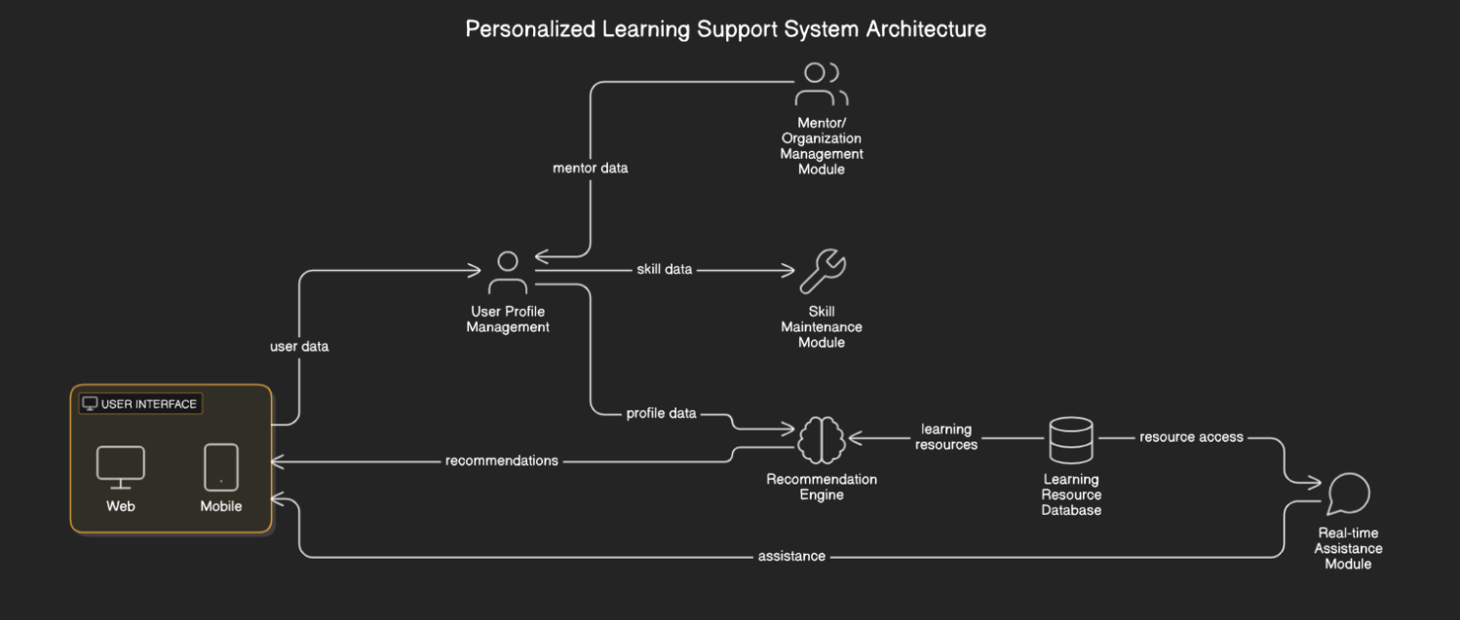

**Figure 2: Personalized Learning Path Generation Process**

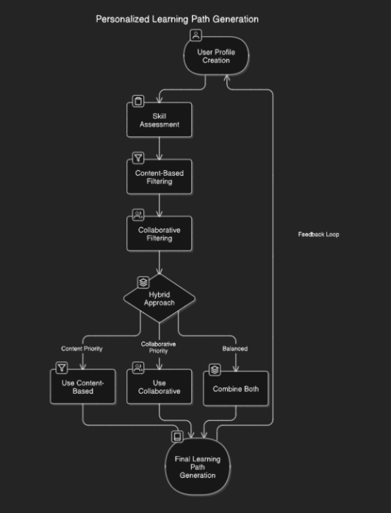

**Figure 3 : Skill Maintenance Module Process**

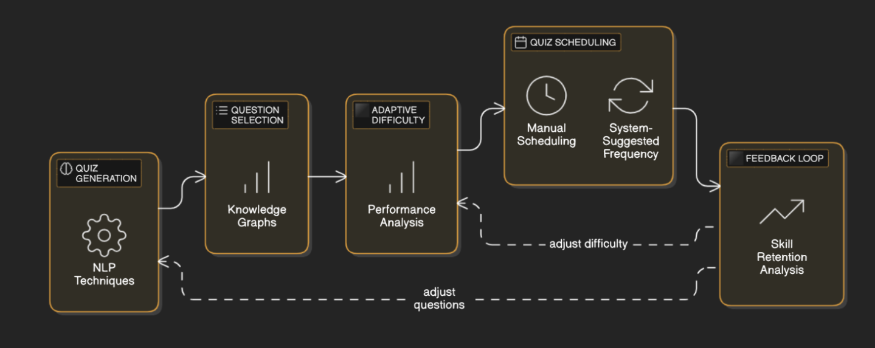

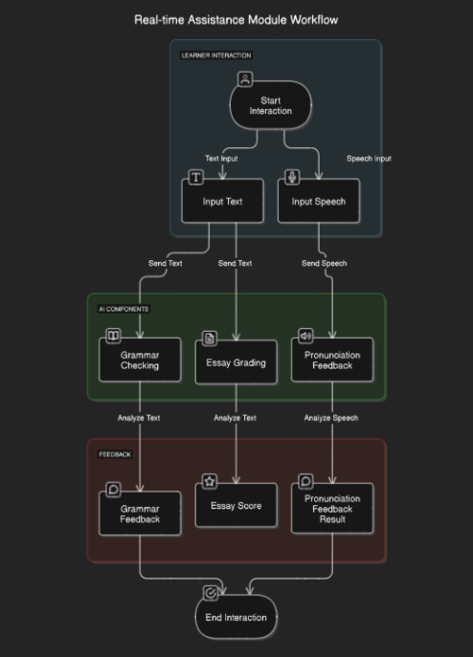**Figure 4: Real-time Assistance Module Workflow**

**Figure 5: Mentor/Organization Management Module**

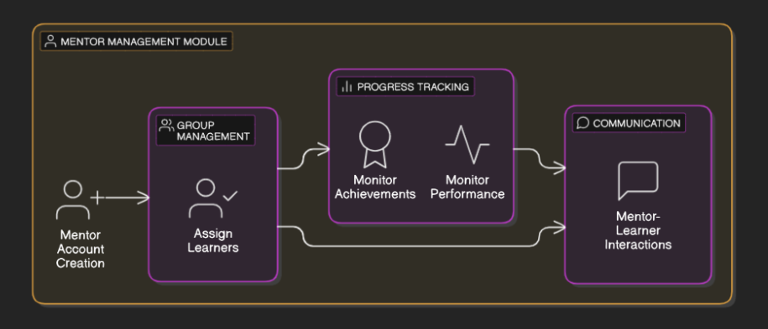

**Figure 6: Recommendation Engine Performance**

**Figure 7: Skill Retention Over Time**

**Figure 8: User Engagement**

**Figure 9: Comparison of Normalized Learning Gains**

**REFERENCES**

[1] Littlejohn, A., & Hood, N. (2018). Reconceptualising learning in the digital age: The changing nature of learning. *International Journal of Learning and Media*, *5*(3), 1-10.

[2] Means, B., Toyama, Y., Murphy, R., & Baki, M. (2013). The effectiveness of online and blended learning: a meta-analysis of the empirical literature. *Teachers college record*, *115*(3).

[3] Kornell, N., & Bjork, R. A. (2008). Learning concepts and facts: Is spacing the “enemy of induction”?. *Psychonomic bulletin & review*, *15*(3), 585-592.

[4] Holmes, W., Bialik, M., & Fadel, C. (2019). *Artificial intelligence in education*. UNESCO.

[5] WEF. (2020). *The Future of Jobs Report 2020*. World Economic Forum.

[6] Roll, I., & Wylie, R. (2016). Evolving from feedback to feed forward to feed up. In *Handbook of research on learning design and learning objects: Issues, applications, and technologies* (pp. 481-507). IGI global.

[7] Littlejohn, A., & Hood, N. (2018). Reconceptualising learning in the digital age: The changing nature of learning. *International Journal of Learning and Media*, *5*(3), 1-10.

[8] Woolf, B. P. (2010). Building intelligent interactive tutors: Student-centered strategies for revolutionizing e-learning. Morgan Kaufmann.

[9] Brusilovsky, P., & Sosnovsky, S. (2005). Individualized access to educational digital libraries. In *Digital Libraries: Implementing Strategies for the Digital Age* (pp. 429-444). Springer.

[10] Yudelson, M., Hockemeyer, C., & Oppermann, R. (2013). Adaptive e-learning: The next generation of learning management systems. In *Proceedings of the 8th International Conference on Web Based Communities and Social Media* (pp. 37-48).

[11] Murre, J. M., & Dros, J. (2015). Replication and analysis of Ebbinghaus’ forgetting curve. *PloS one*, *10*(7), e0120644.

[12] Hwang, G. J. (2014). Definition, framework and research issues of smart learning and ubiquitous learning. *Smart Learning Environments*, *1*(1), 1-25.

[13] Dabbagh, N., & Kitsantas, A. (2012). Personal learning environments, social media, and self-regulated learning: A natural alignment. *The Internet and Higher Education*, *15*(1), 3-8.

[14] Laal, M., & Ghodsi, S. M. (2012). Benefits of collaborative learning. *Procedia-Social and Behavioral Sciences*, *31*, 486-490.

[15] Siemens, G. (2005). Connectivism: A learning theory for the digital age. *International journal of instructional technology and distance learning*, *2*(1), 3-10.

[16] Jannach, D., Zanker, M., Felfernig, A., & Friedrich, G. (2010). *Recommender systems: An introduction*. Cambridge University Press.

[17] Bawden, D. (2001). Information and digital literacies: a review of concepts. *Journal of documentation*.

[18] Dunlosky, J., Rawson, K. A., Marsh, E. J., Nathan, M. J., & Willingham, D. T. (2013). Improving students’ learning with effective learning techniques: Promising directions from cognitive and educational psychology. *Psychological Science in the Public Interest*, *14*(1), 4-58.

[19] Karpicke, J. D., & Blunt, J. R. (2011). Retrieval practice produces more learning than elaborative studying with concept mapping. *Science*, *331*(6018), 772-775.

[20] Chickering, A. W., & Gamson, Z. F. (1987). Seven principles for good practice in undergraduate education. *AAHE bulletin*, *39*(7), 3-7.

[21] Pane, J. F., & Steiner, E. D. (2018). *Personalized learning: What it is and why it matters*. RAND Corporation.

[22] Onah, D. F. O., Sinclair, J., & Boyatt, R. (2018). Dropout rates of online learners: Does prior experience matter?. *Education and Information Technologies*, *23*, 1429-1449.

[23] Ifenthaler, D., & Yilmaz, R. M. (2020). Digital humanism: A call for interdisciplinary research on the digital transformation of education. *British Journal of Educational Technology*, *51*(4), 1032-1049.